Experiment No. 10
Unsupervised Learning: Clustering

1. Aim
To implement K-Means clustering algorithm and identify clusters and centroids from the dataset.

2. Objectives
- To understand the concept of clustering in machine learning.
- To study the K-Means clustering algorithm.
- To group data points into clusters based on similarity.
- To identify cluster labels and centroids.
- To predict cluster membership for new data points.

3. Software Required
- Python 3.x
- Jupyter Notebook / Google Colab / Anaconda
- NumPy Library
- Scikit-learn Library
- Matplotlib Library

4. Introduction
Clustering is an unsupervised machine learning technique used to group similar data points without predefined labels.
K-Means is one of the most widely used clustering algorithms. It partitions data into K clusters such that each data point belongs to the cluster with the nearest centroid.

Applications of K-Means
Application | Purpose
Customer Segmentation | Group customers
Image Compression | Reduce colors
Market Analysis | Identify patterns
Document Clustering | Group similar documents

5. K-Means Algorithm
K-Means minimizes the distance between data points and cluster centroids.

Objective Function
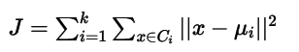
Where:
- CiC_iCi​ → Cluster
- μi\mu_iμi​ → Centroid of cluster
6. Steps in K-Means Clustering
- Import required libraries
- Define dataset
- Select number of clusters (K)
- Initialize centroids
- Assign data points to nearest centroid
- Update centroid positions
- Repeat until convergence

7. Dataset Description
A simple two-dimensional dataset is used.
Feature 1 | Feature 2
1 | 2
1 | 4
1 | 0
10 | 2
10 | 4
10 | 0
The dataset naturally forms two clusters.

8. Dataset Characteristics
- Number of Samples: 6
- Number of Features: 2
- Number of Clusters: 2
- Type of Problem: Unsupervised Learning

9. Learning Objective
To understand how K-Means clustering groups similar data points and determines cluster centers automatically.

10. Program
# Import Libraries
import numpy as np
import matplotlib.pyplot as plt
from sklearn.cluster import KMeans

# Dataset
X = np.array([
[1, 2],
[1, 4],
[1, 0],
[10, 2],
[10, 4],
[10, 0]
])
kmeans = KMeans(n_clusters=2, random_state=0)
kmeans.fit(X)
labels = kmeans.labels_
centroids = kmeans.cluster_centers_
print("Cluster Labels:", labels)
print("Centroids:\n", centroids)
plt.scatter(X[:, 0], X[:, 1], c=labels, cmap='viridis', s=100)
plt.scatter(
centroids[:, 0],
centroids[:, 1],
color='red',
marker='X',
s=200
)
plt.title("K-Means Clustering")
plt.xlabel("Feature 1")
plt.ylabel("Feature 2")
plt.show()

Output:
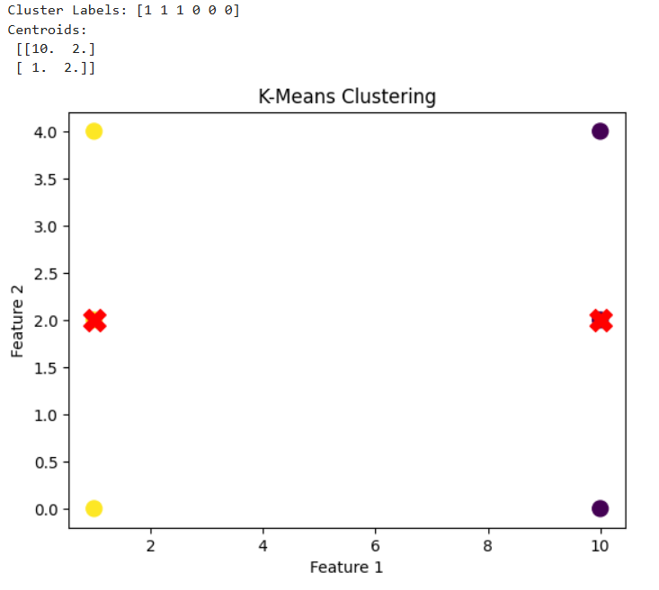

12. Conclusion
K-Means is an efficient and simple clustering algorithm used to group similar data points based on distance. It automatically identifies cluster centers and is widely applied in customer segmentation, image processing, and pattern recognition tasks.

13. Viva Questions

1. What is clustering in machine learning?
Clustering is an unsupervised learning method used to group similar data points.

2. What is K-Means algorithm?
K-Means partitions data into K clusters using centroid-based grouping.

3. What is centroid in K-Means?
Centroid is the mean position of all points in a cluster.

4. What is the role of K in K-Means?
K specifies the number of clusters.

5. What is the objective function in K-Means?
It minimizes the sum of squared distances between points and centroids.

6. What is convergence in K-Means?
Convergence occurs when cluster assignments stop changing.

7. What are advantages of K-Means?
It is simple, fast, and efficient for large datasets.

8. What are limitations of K-Means?
It requires predefined K and is sensitive to outliers.

9. What distance measure is used in K-Means?
Euclidean distance is commonly used.

10. Where is K-Means used in real-world applications?
Customer segmentation, image compression, recommendation systems, and market analysis.

Experiment No. 10.2

K-Means Clustering on Iris Dataset and Elbow Method for Optimal K

1. Aim
To apply K-Means clustering on the Iris dataset and determine the optimal number of clusters using the Elbow Method.

2. Objectives
- To understand clustering on real-world datasets.
- To apply feature scaling before clustering.
- To determine the optimal number of clusters using the Elbow Method.
- To implement K-Means clustering on the Iris dataset.
- To visualize clusters and centroids.

3. Software Required
- Python 3.x
- Jupyter Notebook / Google Colab / Anaconda
- Scikit-learn Library
- Matplotlib Library

4. Introduction
K-Means clustering is a widely used unsupervised learning algorithm for grouping similar data points.
However, one major challenge is selecting the correct number of clusters (K). The Elbow Method is used to solve this problem.
It works by plotting inertia (within-cluster sum of squares) against different values of K. The optimal K is identified at the point where the curve shows a sharp bend called the “elbow.”

5. K-Means and Elbow Method

Objective Function (Inertia)
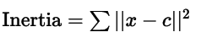
Where:
- xxx → Data point
- ccc → Centroid

Elbow Method
The optimal value of K is chosen where adding more clusters does not significantly reduce inertia.

6. Steps in Building the Model
- Import required libraries
- Load dataset
- Apply feature scaling
- Compute inertia for different K values
- Plot Elbow curve
- Select optimal K
- Apply K-Means clustering
- Visualize clusters and centroids

7. Dataset Description
The Iris dataset is used for clustering.
Attribute | Description
Sepal Length | Length of sepal
Sepal Width | Width of sepal
Petal Length | Length of petal
Petal Width | Width of petal
- The dataset naturally contains 3 clusters (species).

8. Dataset Characteristics
- Number of Samples: 150
- Number of Features: 4
- Expected Clusters: 3
- Type of Problem: Unsupervised Learning

9. Learning Objective
To understand how to determine the optimal number of clusters using the Elbow Method and apply K-Means clustering effectively on real-world datasets.

10. Program
import matplotlib.pyplot as plt
from sklearn.datasets import load_iris
from sklearn.preprocessing import StandardScaler
from sklearn.cluster import KMeans

iris = load_iris()
X = iris.data

sc = StandardScaler()
X_scaled = sc.fit_transform(X)

inertia = []

for k in range(1, 11):
kmeans = KMeans(n_clusters=k, random_state=0)
kmeans.fit(X_scaled)
inertia.append(kmeans.inertia_)

plt.plot(range(1, 11), inertia, marker='o')
plt.title("Elbow Method for Optimal K")
plt.xlabel("Number of Clusters (K)")
plt.ylabel("Inertia")
plt.show()

kmeans = KMeans(n_clusters=3, random_state=0)
labels = kmeans.fit_predict(X_scaled)

centroids = kmeans.cluster_centers_
print("Cluster Labels:\n", labels)
print("\nCentroids:\n", centroids)

plt.scatter(
X_scaled[:, 0],
X_scaled[:, 1],
c=labels,
cmap='viridis'
)

plt.scatter(
centroids[:, 0],
centroids[:, 1],
color='red',
marker='X',
s=200
)

plt.title("K-Means Clustering on Iris Dataset")
plt.show()

Output:
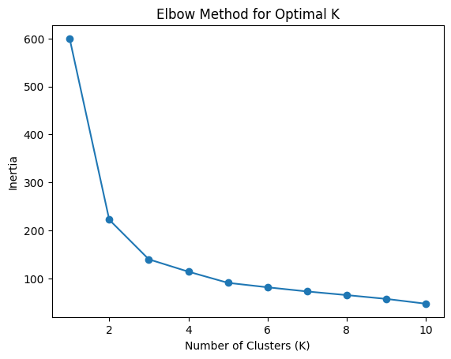
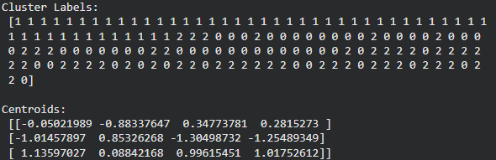
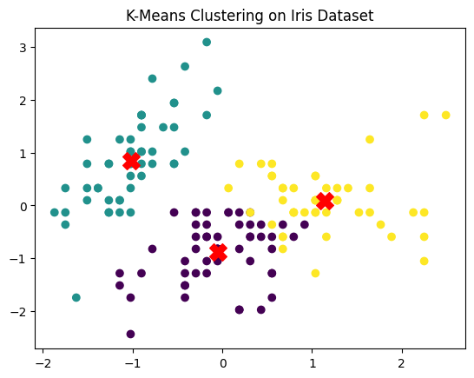

12. Conclusion
The Elbow Method is an effective technique for determining the optimal number of clusters in K-Means clustering. Proper scaling and visualization improve clustering accuracy and help in better interpretation of results on real-world datasets like Iris.

13. Viva Questions

1. What is clustering?
Clustering is an unsupervised learning technique used to group similar data points.

2. What is K-Means algorithm?
K-Means divides data into K clusters based on similarity.

3. What is inertia in K-Means?
Inertia is the sum of squared distances between data points and centroids.

4. What is Elbow Method?
It is a technique used to find the optimal number of clusters.

5. Why is feature scaling required?
It ensures all features contribute equally to distance calculations.

6. How do you choose optimal K?
By identifying the elbow point in the inertia graph.

7. What are centroids?
Centroids are the center points of clusters.

8. What is unsupervised learning?
Learning from unlabeled data without predefined outputs.

9. What are limitations of K-Means?
It is sensitive to initial centroids and requires predefined K.

10. Where is clustering used in real-world applications?
Customer segmentation, image compression, recommendation systems, and pattern recognition.

Experiment 10.3

Agglomerative Hierarchical Clustering Implementation

1. Aim
To implement Agglomerative Hierarchical Clustering and visualize the clustering results.

2. Objectives
- To understand hierarchical clustering.
- To study Agglomerative clustering approach.
- To group data points based on similarity.
- To analyze cluster formation using linkage methods.
- To visualize clustering results.

3. Software Required
- Python 3.x
- Jupyter Notebook / Google Colab / Anaconda
- NumPy Library
- Scikit-learn Library
- Matplotlib Library

4. Introduction
Hierarchical clustering is an unsupervised learning technique used to build a hierarchy of clusters.
There are two types:
- Agglomerative (Bottom-Up approach)
- Divisive (Top-Down approach)
In Agglomerative Clustering, each data point starts as an individual cluster, and clusters are merged step-by-step based on similarity.

5. Agglomerative Clustering Model
Agglomerative clustering uses linkage criteria to merge clusters.

Common Linkage Methods
- Single linkage
- Complete linkage
- Average linkage
- Ward linkage (minimizes variance)

Distance Measure
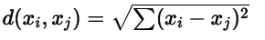
(Euclidean Distance)

6. Steps in Agglomerative Clustering
- Import required libraries
- Define dataset
- Initialize clustering model
- Fit model and predict cluster labels
- Visualize clusters

7. Dataset Description
A small dataset with two numerical features is used.
Feature 1 | Feature 2
4 | 5
10 | 4
3 | 11
14 | 6
10 | 21
19 | 24
17 | 16
25 | 24
22 | 21
8 | 12

8. Dataset Characteristics
- Number of Samples: 10
- Number of Features: 2
- Number of Clusters: 2
- Type of Problem: Unsupervised Learning

9. Learning Objective
To understand how hierarchical clustering groups data points by successively merging clusters based on distance and linkage criteria and visualize the results using a dendrogram.

10. Program
import numpy as np
import matplotlib.pyplot as plt
from sklearn.cluster import AgglomerativeClustering
from scipy.cluster.hierarchy import dendrogram, linkage

X = np.array([
[4, 5],
[10, 4],
[3, 11],
[14, 6],
[10, 21],
[19, 24],
[17, 16],
[25, 24],
[22, 21],
[8, 12]
])

model = AgglomerativeClustering(
n_clusters=2,
linkage='ward'
)

labels = model.fit_predict(X)
print("Cluster Labels:", labels)
linked = linkage(X, method='ward')

plt.figure(figsize=(8, 5))
dendrogram(linked)

plt.title("Dendrogram for Hierarchical Clustering")
plt.xlabel("Data Points")
plt.ylabel("Euclidean Distance")

plt.show()

plt.scatter(
X[:, 0],
X[:, 1],
c=labels,
cmap='rainbow'
)

plt.title("Agglomerative Clustering Result")
plt.xlabel("Feature 1")
plt.ylabel("Feature 2")

plt.show()

Output:
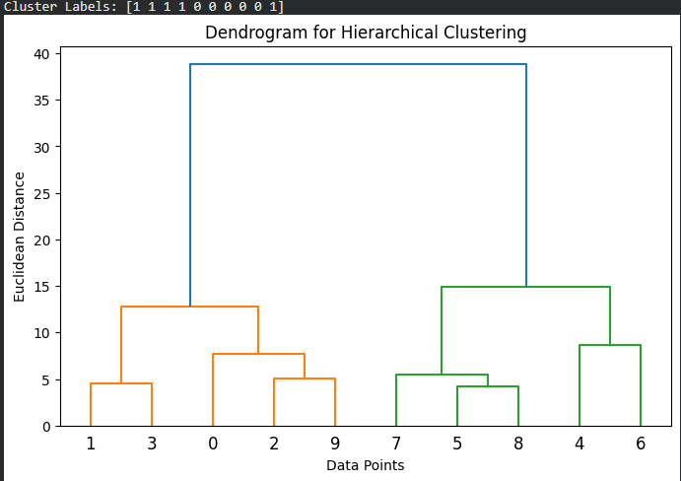
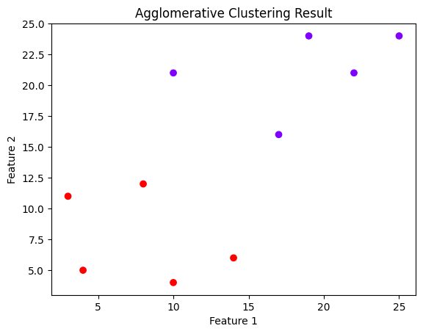

12. Conclusion
Agglomerative Hierarchical Clustering is an effective unsupervised learning technique that builds clusters step by step based on similarity. It is useful for exploratory data analysis and helps visualize relationships using dendrograms.

13. Viva Questions

1. What is hierarchical clustering?
Hierarchical clustering is an unsupervised learning method that builds a tree-like structure of clusters.

2. What is Agglomerative clustering?
It is a bottom-up approach where each data point starts as a cluster and merges step by step.

3. Difference between Agglomerative and Divisive clustering?
Agglomerative merges clusters, while divisive splits clusters.

4. What is linkage in clustering?
Linkage defines how distance between clusters is calculated.

5. What is Ward linkage?
Ward linkage minimizes variance within clusters.

6. What is Euclidean distance?
It is the straight-line distance between two points.

7. What is a dendrogram?
A tree-like diagram that shows hierarchical clustering structure.

8. Advantages of hierarchical clustering?
No need to specify K and easy visualization using dendrogram.

9. Limitations of hierarchical clustering?
It is computationally expensive and not suitable for large datasets.

10. Where is hierarchical clustering used?
It is used in gene analysis, customer segmentation, image grouping, and document clustering.

Experiment No. 10.4

Density-Based Clustering using DBSCAN Algorithm

1. Aim
To implement DBSCAN clustering and identify clusters in a non-linearly separable dataset.

2. Objectives
- To understand density-based clustering.
- To study the DBSCAN algorithm.
- To identify clusters of arbitrary shapes.
- To detect noise and outliers.
- To visualize clustering results.

3. Software Required
- Python 3.x
- Jupyter Notebook / Google Colab / Anaconda
- Scikit-learn Library
- Matplotlib Library

4. Introduction
DBSCAN (Density-Based Spatial Clustering of Applications with Noise) is a clustering algorithm that groups together data points that are closely packed and marks points in low-density regions as outliers.
Unlike K-Means, DBSCAN:
- Does not require specifying the number of clusters in advance
- Can detect clusters of arbitrary shapes
- Is robust to noise and outliers
It is widely used in real-world applications where data is irregularly distributed.

5. DBSCAN Algorithm
DBSCAN works based on two key parameters:
- eps (ε) → Radius of neighborhood
- min_samples → Minimum number of points required to form a dense region

Distance Measure
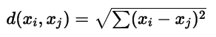

Types of Points
- Core Points → Points with sufficient neighbors
- Border Points → Points near core points
- Noise Points → Outliers (not part of any cluster)

6. Steps in DBSCAN Clustering
- Import required libraries
- Generate dataset
- Visualize dataset
- Apply DBSCAN algorithm
- Predict cluster labels
- Visualize clustered data

7. Dataset Description
A synthetic dataset is generated using circular patterns.
- Created using make_circles()
- Dataset is non-linearly separable
- Ideal for DBSCAN clustering

8. Dataset Characteristics
- Number of Samples: 500
- Number of Features: 2
- Type of Problem: Unsupervised Learning
- Dataset Type: Non-linear

9. Learning Objective
To understand how DBSCAN identifies clusters of arbitrary shapes and detects noise without requiring the number of clusters beforehand.

10. Program
import matplotlib.pyplot as plt
from sklearn.datasets import make_circles
from sklearn.cluster import DBSCAN
from sklearn.preprocessing import StandardScaler
X, y = make_circles(
n_samples=500,
noise=0.05,
factor=0.5
)
X = StandardScaler().fit_transform(X)
dbscan = DBSCAN(
eps=0.3,
min_samples=5
)

labels = dbscan.fit_predict(X)
print("Cluster Labels:\n", labels)

plt.scatter(
X[:, 0],
X[:, 1],
c=labels,
cmap='rainbow'
)

plt.title("DBSCAN Clustering Result")
plt.xlabel("Feature 1")
plt.ylabel("Feature 2")

plt.show()

Output:
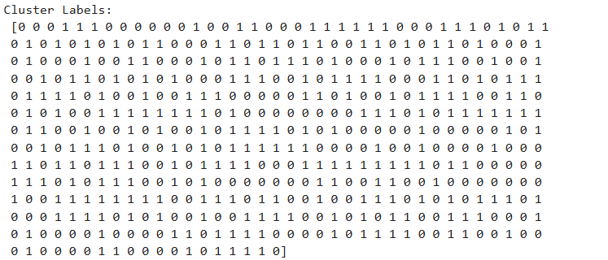
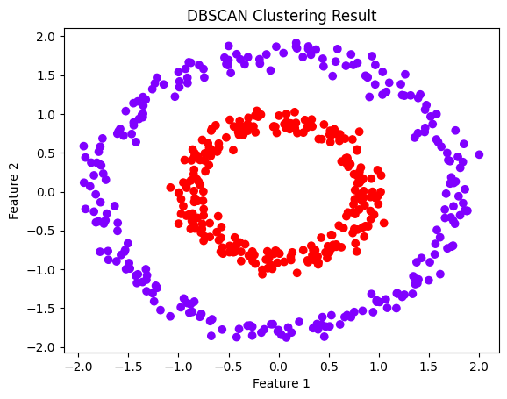

12. Conclusion
DBSCAN is a powerful density-based clustering algorithm that effectively identifies clusters of arbitrary shapes and detects noise points. It is highly suitable for non-linear datasets where traditional algorithms like K-Means fail.

13. Viva Questions

1. What is DBSCAN?
DBSCAN is a density-based clustering algorithm used to group dense regions and detect noise.

2. What are eps and min_samples?
eps defines neighborhood radius and min_samples defines minimum points required to form a cluster.

3. What are core, border, and noise points?
Core points have many neighbors, border points are near clusters, and noise points are outliers.

4. How is DBSCAN different from K-Means?
DBSCAN does not require number of clusters and can detect noise, unlike K-Means.

5. What type of clusters can DBSCAN detect?
It can detect clusters of arbitrary shapes.

6. What is density-based clustering?
Clustering based on density of data points in a region.

7. Advantages of DBSCAN?
No need to specify K, handles noise, and detects complex shapes.

8. Limitations of DBSCAN?
It struggles with varying density datasets and high-dimensional data.

9. What distance measure is used in DBSCAN?
Typically Euclidean distance.

10. Where is DBSCAN used in real-world applications?
It is used in anomaly detection, spatial data analysis, GPS clustering, and fraud detection.

